**STOP/INTREPID Teleconference: Wednesday, September 6, 2023, 1:00-2:00 pm**

# Land Acknowledgment:

* Identify the land you are joining us from today ([**https://www.whose.land/en/**](https://www.whose.land/en/))
* Video: [Bringing meaning and purpose to land acknowledgements](https://www.facebook.com/CentreforAddictionandMentalHealth/videos/bringing-meaning-and-purpose-to-land-acknowledgements/759567845184040/)

Summary of August 2 meeting:

* Reminder of upcoming STOP Portal data partition; new self-enrollment patient invitation letter; 1st edition of the [Intrepid Lab Newsletter](https://createsend.com/t/y-FBDE72523E55271B2540EF23F30FEDED) – please [opt in](https://confirmsubscription.com/h/y/5901866DB84AF1E0) to receive them

# TEACH Updates:

* [IT'S TIME toolkits](https://www.nicotinedependenceclinic.com/en/teach/practitioner-resources)
  + Offers community workers and members culturally-relevant commercial tobacco reduction/cessation tools
  + A model of collaboration and integration between evidence-based reduction/cessation resources, and Indigenous ways of learning and knowing
  + **All materials can be freely copied, shared and adapted, in accordance with Ownership, Control, Access and Possession (OCAP) principles**
* [E-cigarettes and vaping: approaches to address use with adults and youth](https://www.nicotinedependenceclinic.com/en/teach/course-descriptions)
  + Sep 20-Oct 25, 2023
  + $400
  + Same course as held previously
* [Self-study courses](https://www.nicotinedependenceclinic.com/en/teach/self-study-modules)
* **What clinicians really need to know about vaping cessation among youth**
  + Recording available [here](https://www.nicotinedependenceclinic.com/en/teach/Pages/TEACH-Rounds-Archive.aspx)

# STOP Updates:

# All organizations

# Returned/expired NRT: if you send any back to CAMH for disposal, it must be in the original box

# French translations: if anybody notices any translations that don’t make sense, please let us know

# Labour issues: if you anticipate any upcoming disruptions to STOP treatment/patient care due to labour issues, please contact STOP to see if we can offer assistance

# STOP at Long Term Care Homes

# [Long Term Care Homes (LTCH) can partner with STOP](https://www.nicotinedependenceclinic.com/en/stop/Documents/LTC%20Poster.pdf) to provide residents with up to 26 weeks of no-cost Nicotine Replacement Therapy, plus access training opportunities available for practitioners

# Support is also available for community agencies assisting LTCH wait-listed residents, such as Home and Community Care organizations

# If you are a LTCH interested in implementing the STOP Program, please email us at [stop.ltc@camh.ca](mailto:stop.ltc@camh.ca) and [click here](https://edc.camhx.ca/redcap/surveys/?s=LE478TREKDRNFHXM) to complete a capacity assessment survey

# STOP on the Net (SOTN)

# Expanding to 10 weeks of treatment: as of September 2nd, STOP on the Net has expanded to a 10-week treatment program (previously 8 weeks). Eligible participants now receive 10 boxes of NRT patches and 5 boxes of NRT gum or lozenges.

# Survey changes: Two new demographic questions on race & immigrant status have been added to the SOTN baseline questionnaire.

1. **New PHU advertising campaign**: We have just launched another advertising campaign for Public Health Units. We will reimburse up to **$1,000/health unit** for spending toward **SOTN promotional activities** between **now** and **March 1, 2024**.

# Please note: SOTN is only available to individuals who smoke tobacco cigarettes (this program is not offered for people who only use e-cigarettes)

# STOP Portal

# Computer specifications:

# Any organizations using the STOP Portal should be using Windows 10 (or later), as previous versions are not supported by Microsoft and may be security risks. See [here](https://endoflife.date/windows) for more information. You should also use the newest versions of Chrome, Firefox or Edge that your operating system can support.

# When ordering NRT, make sure to enter your full address in the ‘comments’ section

# STOP data partitioning v2.0 (see below)

**PLEASE READ: STOP data partitioning v2.0:**

* As per our REB requirements, STOP *Program* records (August 27, 2022 and later enrollees) **should not** be stored alongside STOP *Study* records (August 26, 2022 and earlier enrollees). The STOP *Study* records must be kept in a separate offline database (CAMH Team access only)
* In order to fulfill these requirements while ensuring minimal interruptions to clinical care, the transfer of STOP *Study* data to the offline database is being done in two phases:

**~~Phase 1:~~** ~~All~~ ***~~completed~~*** ~~study enrollments (any enrollees from July 28, 2021 and earlier).~~ *~~We completed this on Oct 21, 2022.~~*

**Phase 2: Study enrollments from July 29, 2021 to August 26, 2022) will be transferred once their enrollment period is complete.** *This transfer scheduled for Sep 27, 2023.*

Please see visual below for an overview of the data partitioning timelines.

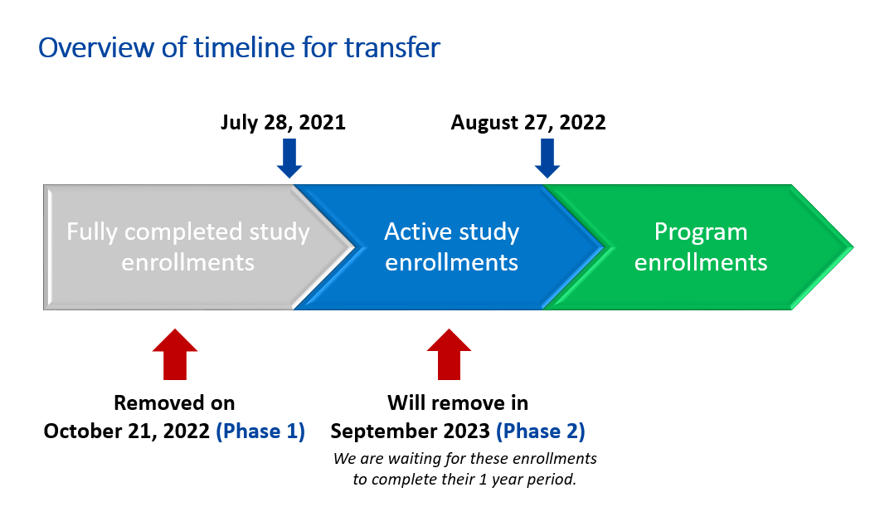

**What does this mean for you?**

* **As of September 27, 2023** all participants who enrolled on August 26, 2022 or earlier will no longer be accessible via the STOP Portal:
* This includes any visits/follow-ups tied to the participant’s enrollment (even if they took place after August 26, 2022)

**In the STOP Portal, these participants *will not be included* in:**

* Patient Searches
* Dashboard enrollment summary & list of recent encounters
* Feedback reports
* Note: NRT Order records on or before August 26, 2022 will be removed
* Note 2: Inventory Log section for old visits will remain available in a limited form – you will be able to see the NRT given out and date, but not the participant’s ID

**What can I do to prepare?**

* Your organization should **download feedback reports** for these data (July 29, 2021 – August 26, 2022 data will be removed)
  + Note: Feedback reports will continue to remain available in the STOP Portal for enrollments from August 27, 2022 onwards
* Count your inventory and make sure all visits are entered and all past orders are accepted!
* Note: we will be sending notifications to all organizations that their Study agreements will end Sep 26, 2023; if you are currently enrolling patients, you don’t not need to do anything as you already have a Program agreement which took effect Aug 27, 2022

STOP Portal Q&A:

**Q: What is the STOP Portal feedback report used for?**

A: This report provides data on enrollment, visit, and follow-up information collected for each specific organization and can be useful for things such as year-end reporting. You can download yours by going to the menu bar in the STOP Portal 🡪 click on Reporting 🡪 View Reports 🡪 Feedback report 🡪 enter the time frame of interest. If you haven’t already, your organization should **download feedback reports** for data that are being removed (July 29, 2021 – August 26, 2022 data).

**Q: When re-enrolling a client, do we put R1, R2, etc. before the client number?**

A: Yes, please continue to do this if possible. It may become more difficult determine which R# to use once more data is removed from the portal, but try to do your best. Your best guess is completely fine. We have other ways of identifying which patients have had multiple enrollments.

**Q: Some practitioners continue to have a glitch when trying to select ‘women’ for Question 2a in the registration form. Any solutions?**

A: We are currently unable to consistently reproduce this issue but if you can do so, please let us know so we can try and fix it.

**Q: If Option B is selected at baseline, does the questionnaire lock or can answers be entered on-site after?**

A: If you select option B and then record the baseline questions on paper, please reach out to a STOP RC so we can ‘unlock’ your survey and allow you to enter the information into the portal (instead of mailing it to us).

**Q: If a client was only vaping at enrollment and using NRT to quit vaping, do we still fill out “0” cigarettes per day in the visit form, even if they are still vaping during the follow-up?**

A: Yes, the questions in the visit forms are specific to cigarettes only. For now, you can record this additional information in the ‘comments’ as necessary.

General Q&A:

**Q: Does anybody have any cannabis and tobacco resources to share?**

A: If so, please contact the STOP team so that we can share them.

**Q: A practitioner not involved in STOP has recommended cutting NRT patches in half to lower the dose and not have to purchase new patches. Have you heard this and is it recommended?**

A: STOP cannot recommend cutting patches in half (e.g., dosing will not be precise).

**Q: What counts as “Homes of Community Care” organizations? Could this include the following: domestic hostels, group homes that require a prescription, retirement homes?**

A: At this time, we are partnering with Long-Term Care Homes, not retirement homes. Home and Community Care organizations are organizations that work with residents waitlisted for Long-Term Care Homes. Other types of organizations can contact STOP directly ([STOP.ltc@camh.ca](mailto:STOP.ltc@camh.ca)) to inquire if they are eligible.

**Q: Any plan to engage with long-term care pharmacy providers (ex. CareRx, Medisystem, etc.)?**

A: At this time, there are no plans to engage with pharmacy providers.

**Q: Patients can only enroll in one or the other (STOP Program or STOP on the Net), correct? Is there a reason STOP on the Net cannot be used as a bridge?**

A: STOP on the Net was designed to assist those who are unable to access the 26-week STOP Program, e.g., due to location, organizational requirements etc. If you enroll in one program, after the 1-year program expiry has been reached, you can then try to enroll in the other (as long as you meet eligibility criteria).

* Some practitioners suggest the Ottawa Smoking Cessation Community program, which can support clients who have finished the STOP Program and are waiting to enroll in STOP on the Net (note: only provides 6 weeks of free NRT)
* One practitioner noticed that for those who are successful, it only takes about 13 weeks to stop smoking

News:

Zawertailo L, Kouzoukas E, Fougere C, Dragonetti R, Veldhuizen S, Selby P. **Clinical guidance for e-cigarette (vaping) cessation: results from a modified Delphi panel approach.** Preventive Medicine Reports. 2023;19:102372. [**Open access link**](https://doi.org/10.1016/j.pmedr.2023.102372)

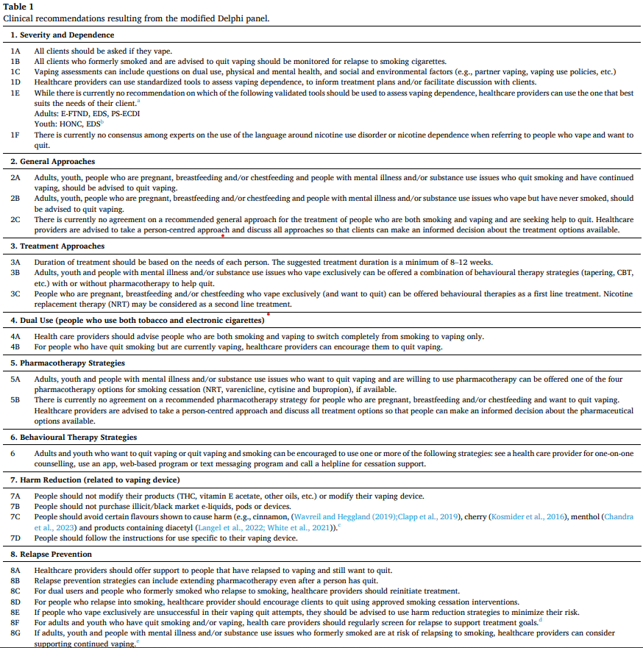

[Teens develop respiratory problems within 30 days of using e-cigarettes, new study finds](https://www.yahoo.com/lifestyle/teens-develop-respiratory-problems-within-223646894.html)

[These vape pens look like school supplies — and they’re being used in plain sight](https://www.schoolhealthny.com/site/default.aspx?PageType=3&ModuleInstanceID=169&ViewID=7b97f7ed-8e5e-4120-848f-a8b4987d588f&RenderLoc=0&FlexDataID=8819&PageID=1)

[Canada marks two years of single-game sports betting with concerns from researchers](https://ca.news.yahoo.com/canada-marks-two-years-single-203117750.html)

### Resources:

**STOP Practitioner Resources Webpage**:

[**https://www.nicotinedependenceclinic.com/en/stop/implementer-resources**](https://www.nicotinedependenceclinic.com/en/stop/implementer-resources)

# 2023 teleconference schedule:

|  |  |  |  |
| --- | --- | --- | --- |
| ~~January 11~~ |  | ~~February 1~~ | ~~February 15~~ |
| ~~March 1~~ | ~~March 15~~ | ~~April 5~~ | ~~April 19~~ |
| ~~May 3~~ | ~~May 17~~ | ~~June 7~~ | ~~June 21~~ |
| ~~July 5~~ | ~~July 19 cancelled~~ | ~~August 2~~ | ~~August 16 cancelled~~ |
| ~~September 6~~ | **September 20** | October 4 | October 18 |
| November 1 | November 15 | December 6 |  |

Fun Story:

[Canada's rudest city is in Ontario: survey](https://www.cp24.com/news/canada-s-rudest-and-most-polite-cities-are-located-in-ontario-1.6526050)

Fun Poll:

***If you had to be trapped in a room with one of these, which would you choose?***

* *Rats* *16/52 = 31%*
* *Snakes 12/52 = 23%*
* ***Bugs 24/52 = 46%***

# Attendance:

# Anishwabe Mushkiki AHAC

# Algoma PHU

# Algonquin FHT

# Arnprior and District FHT

# Athens FHT

# Bancroft FHT

# Barrie Native Advisory Circle

# Black Creek CHC

# Blue Sky FHT

# Burlington FHT

# Carepoint CHC

# Carlo Fidani RCC

# Caroline FHT

# Casey House

# Central CHC

# CHIRS AMHA

# City of Kawartha Lakes FHT

# CMHA Algoma

# CMHA Huron Perth

# CMHA Ottawa

# CMHA Toronto

# CMHA Windsor

# Couchiching FHT

# Credit Valley FHT

# De dwa da dehs nyes AHAC

# Dufferin Area FHT

# Durham Region PHU

# Erie St. Clair AA

# Eastern Ontario PHU

# Fort William FHT

# Georgian Bay FHT

# Grandview Medical Centre FHT

# Grey Bruce PHU

# Guelph FHT

# Haldimand FHT

# Hamilton FHT

# Hamilton PHU

# Hamilton-Niagara CHC

# Happy Valley FHT

# Haven Toronto

# Health for All FHT

# Homewood Community AA

# Humber River FHT

# Huronia NPLC

# Kawartha Lakes CHC

# KFL&A PHU

# Kingston CHC

# Kirkland District FHT

# Lakeview FHT

# Leeds and Grenville FHT

# LMC Pharmacy

# London InterCHC

# Maitland Valley FHT Middlesex-London PHU

# Mount Forest FHT

# Niagara North FHT

# North Bay NPLC

# North Durham FHT

# North Huron FHT

# North York FHT

# Northeastern Manitoulin FHT

# Northumberland FHT

# Northwestern PHU

# Owen Sound FHT

# Parkdale CHC

# Peterborough FHT

# Pinecrest Queensway CHC

# Prime Care FHT

# Queen’s Square FHT

# Rainbow Valley CHC Renascent AA

# Rideau CHC

# Sauble FHT

# Scarborough A FHT

# Seaway Valley CHC

# Sherbourne FHT

# Simcoe Muskoka PHU

# Six Nations AHAC

# South East Toronto FHT

# Southlake RCC

# Stonegate CHC

# Stratford FHT

# Sudbury PHU

# Summerville FHT

# Sundridge Medical Centre

# Superior FHT

# Taddle Creek FHT

# Temiskaming CHC

# Thames Valley FHT

# Thamesview FHT

# The Bridge AA

# Tungasuvvingat Inuit

# Twin Bridges NPLC

# Upper Canada FHT

# Vaughan CHC

# Vitanova Foundation

# West Elgin CHC

# West Nipissing CHC

# Windsor Essex PHU